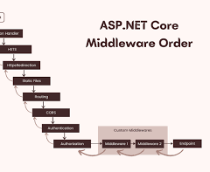
A middleware pipeline is a chain of components in an application (notably ASP.NET Core) that handles incoming HTTP requests and outgoing responses. Each component can inspect, modify, or pass the request to the next component, or "short-circuit" the pipeline by returning a response early, functioning like a bidirectional assembly line
Temenos +2
.
This video explains how the ASP.NET Core middleware pipeline works:

58s


Frank Liu
YouTube• 13 Jan 2025

Key Concepts
- Request & Response Flow: Requests pass through the middleware in the order they are configured (top to bottom), and responses travel back through them in reverse order
codewithmukesh
.
- Component Roles: Each component can execute logic before and after the next component in the chain, enabling tasks like logging, authorization, or compression

- Short-Circuiting (Terminal Middleware): A middleware can choose not to call the next component (e.g., UseStaticFiles or authentication failure), immediately returning a response
.
- Order Matters: The order of middleware registration in Program.cs is critical for correct functionality (e.g., Exception Handling should be first, Auth after Routing)
Microsoft Learn
.

Common Built-in Middleware (ASP.NET Core)
- ExceptionHandler: Catches exceptions .
- Hsts/HttpsRedirection: Security enhancements
- StaticFiles: Serves files without hitting backend logic
- Routing: Matches requests to endpoints .
- Authentication/Authorization: Validates user identity .
- Endpoints: Executes endpoint logic

